Executive Training, Life Coaching Consultant, & Mindfulness Teacher
‘Positive Mindset Workshop’
Motivational, Inspirational, Educational & Fun
What’s Another Year?
20/20 Vision
Learn Techniques to Handle Anxiety & Stress
Plan Realistic & Achievable Goals
Turn Thoughts and Dreams into Positive Actions
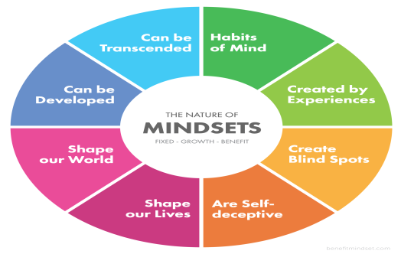
Oak Centre
Maynooth Road, Dunboyne
Sunday January 5th 2020
2.00pm to 5.00pm
Admission €50.00
Eventbritehttps://www.eventbrite.ie/e/positive-mindset-workshop-tickets-85078645519
To find out more call Marian 087 6359787

